Morgan Stanley Photo Competition Judges 2017

Karen McQuaid, Curator, The Photographers’ Gallery

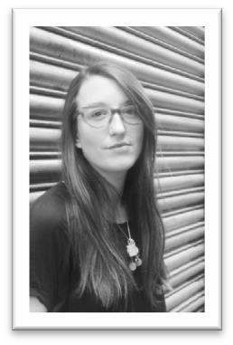Karen McQuaid is Curator at The Photographers’ Gallery and has been in post since 2009. Previous to her appointment as Curator she worked extensively on the talks and lectures strands at the gallery- co-organising the symposium Contemporary Vernacular Photogaphies with the Institute of Modern and Contemporary Culture in 2011. Karen has curated exhibitions such as Jim Goldberg, Open See (2009); Fiona Tan, Vox Populi London (2012); and Claire Aho, Studio Works (2013). She co-curated Geraldo deBarros, What Remains (2013), and has also facilitated a number of Soho community artists projects, collaborating with artists such as Virginia Nimarkoh.

Karen regularly writes for international arts publications and institutions, and guest lectures across the UK. For more information on The Photographers’ Gallery please visit www.thephotographersgallery.org.uk

Mandell L. Crawley, Managing Director, Global Chief Marketing Officer, Morgan
Stanley

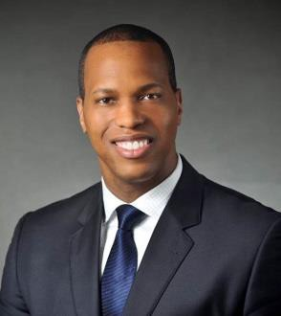Mandell L. Crawley joined Morgan Stanley in October 1992 as a High School Intern and now serves as Global Chief Marketing Officer for the Firm. In this role, he has overall responsibility for defining, creating, and delivering Morgan Stanley’s marketing strategy. This includes shaping and enhancing the company’s brand value, ensuring the global integration and consistency of marketing strategy across businesses, functions and geographies to deliver growth and value.

Prior to this assignment, Mr. Crawley was Head of National Business Development and Talent Management for Morgan Stanley Wealth Management where he led an organization responsible for driving revenue and asset growth across the firm’s industry leading platform and improving the proficiency of our financial advisors, sales support, and field leadership talent.

Mandell was also Head of U.S. Fixed Income Sales & Distribution for Morgan Stanley Wealth Management’s Capital Markets Group, overseeing a large coverage team across all debt asset classes. In aggregate he spent 14 of his 23 years working within Fixed Income Capital Markets in various producing
& managerial capacities.

He is a member of the Firm’s Management Committee, Global Wealth Management Operating Committee, the Multicultural Client Strategy Committee and a board member of the Covenant House NY which is leading the fight against youth homelessness.

Mandell received an MBA with honors from Fordham University (New York City) and a B.A. in Economics from Northeastern Illinois University (Chicago). He resides in Westchester County, NY with his wife Alison, and twin daughters, Jordyn and Jaedyn. Mandell is a proud native of Chicago, IL.

Andrea Dowling, Managing Director of Morgan Stanley and EMEA Head of
Infrastructure HR Coverage and EMEA Head of Talent Management

 Andrea is a Managing Director of Morgan Stanley and EMEA Head of Infrastructure HR Coverage and EMEA Head of Talent Management, based in London.

Andrea joined the Firm in 1996 as an Associate in Human Resources, again in London, serving in a number of coverage roles within Human Resources. She was named Vice President in 1999, Executive Director in 2002 and Managing Director in 2014.

Previously, Andrea worked for PricewaterhouseCoopers from 1989 until 1994 and then for Hambros Bank from 1994 to 1996. Andrea earned an Honours degree in Modern History and Politics, graduating in 1989 from the University of Liverpool.

She resides in London with her husband, Peter and their three children.

KC Wong, Head of Asia Pacific Community Affairs, Internal Communications and
Marketing

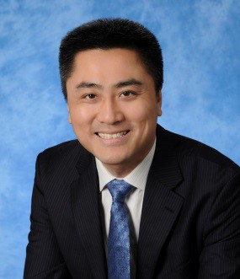KC Wong is Head of Asia Pacific Community Affairs, Internal Communications and Marketing, based in Hong Kong. He oversees the Firm’s Philanthropy Committees across eight markets and serves as regional contact for the Firm’s Environment and Social Finance Forum initiatives.

In October 2016, KC joined Morgan Stanley from Swiss Reinsurance where he was Asia Pacific Head of Communications responsible for developing and implementing the group’s regional marketing and communications strategy, with overall responsibility for the
reinsurer’s CSR programs, internal communications, marketing and public relations. Before joining Swiss Re in
2008, he spent eight years working for Hong Kong’s Securities and Futures Commission, primarily in External
Relations roles.

KC is a CFA Charterholder and a Fellow of the Association of Chartered Certified Accountants (ACCA). He also holds an MPhil in Economics from The Chinese University of Hong Kong. He is a passionate traveler of 80+ countries and a photography lover.

